Case1:removing cargo

Preconditions: There must be 2 branch at least that created by the admin and there is a cargo infos added by the branch employee,

Expected result: After removed the cargo,if branch employe want to remove same cargo that have the same track id ,programmust give us an error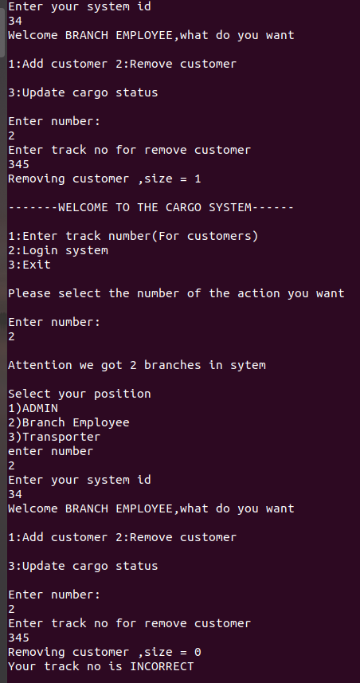

Case2:entering new customer with cargo,and customer enter with id no

Preconditions: there must be a branches and b.employee,

Expected: b.employee must enter cargo with its infos and customer enter with id no to see infos of the cargo

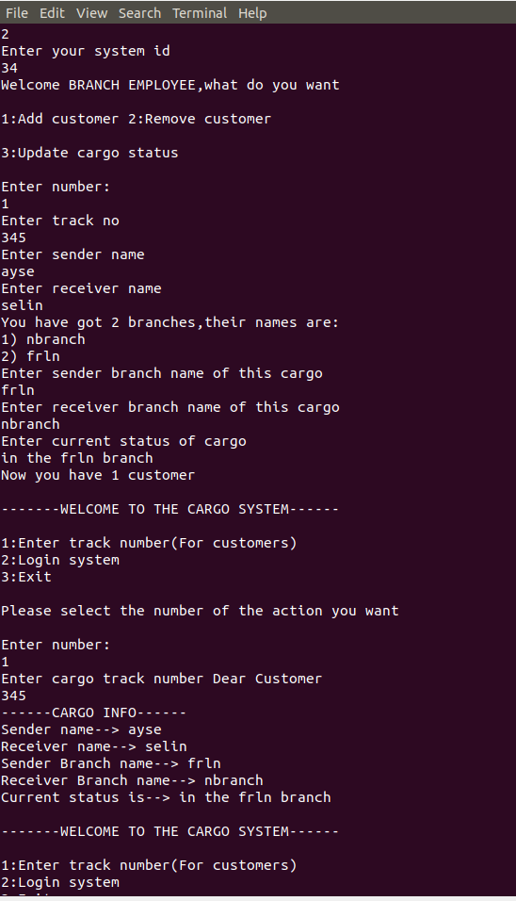

Case3:Invalid select

Precondition:user entered the program

Expected:If user select wrong number ,program must give an error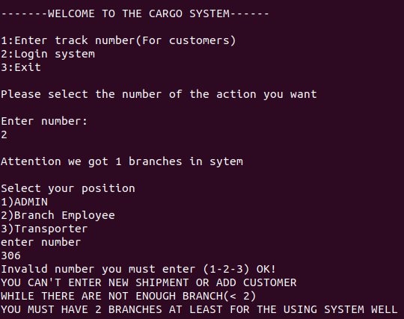

Case4:Transporter adding

Precond.:There must be at least 2 branches added by the admin,

Expected:Admin can add transport employee with its id

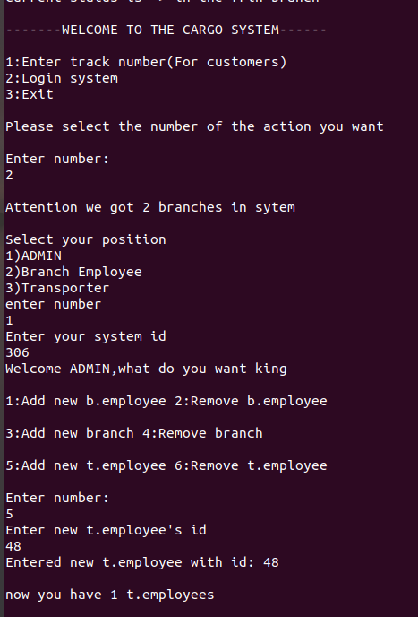

Case5:Admin adds branch

Precondition:Admin must know his enterance id,end entered system

Expected:Admin can add new branch with its name